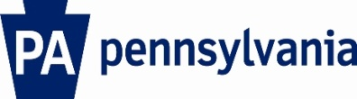

Commonwealth of Pennsylvania

Milk Marketing Board
2301 North Cameron Street – Room 110
Harrisburg, PA 17110-9408

717-787-4194
FAX -717-783-6492
WEB SITE: http://www.mmb.state.pa.us
E-mail: RA-pmmb@pa.gov

License Year 2020-2021

SUBDEALER SURVEY

The Pennsylvania Milk Marketing Board is conducting a review of sales by Subdealers doing business in Pennsylvania. All survey forms are subject to audit. This information is usually available from your supplying dealer. Include all packaged milk and cream products sold “only” in Pennsylvania for the calendar year 2019.

SUPPLYING DEALER NAME | DEALER LICENSE NUMBER | DEALER  CITY, STATE | TOTAL QUARTS SOLD IN PENNSYLVANIA
1.
2.
3.
4.
5.

Please return this form to the above address by June 15, 2020. You may also submit this information via Fax (717-783-6492) or email (RA-PMMB@pa.gov). If you have any questions or concerns regarding this survey, please call Cliff Ackman at 717-787-4021. Thank you.

Sub-dealer Name:
(Print or Type Name)
PMMB License Number:
Contact Person:
Telephone Number:

(Authorized Signature)

